Introduction
The Jinja District health office oversees activities of 84 health facilities; 29 private and 55 public. There are five HSDs to which the health facilities should submit and report.
The top five causes of morbidity in the district are: No pneumonia- cough or cold, Malaria, Intestinal worms, Urinary Tract infections and Diarrhea acute.
The core health sector development plan indicators which are monitored by the health sector on a routine basis include some of the following: Antenatal 4th visit, child immunization with measles and PCV3 antigens, supervised deliveries, Fresh Still Birth rate, TB treatment success rate (TSR), linkage of HIV positive individuals to HIV care, ARV coverage for HIV positive pregnant women, the transmission rate of HIV from an infected mother to her baby and reporting rates especially the integrated disease surveillance response system.
We therefore show the progress made towards attaining the set targets of the above coverage interventions as well as the impediments to progress in the FY 2019/2020.

Performance
The expected number of pregnancies in the district for financial year 2019/2020 was 5% of the projected population and this translates to 25,917. All the expected pregnant women attended at least first ANC which is 100%. However the numbers reduced for those who attended more than 4 visits to 42%. This is unacceptably low especially in line with the Ministry of Health recommendation that a pregnant woman should have at least 8 contacts with the health system before delivery. This low attendance could be attributed to the women not starting attendance of ANC early in the first 3 months of pregnancy (1st trimester). The women who attended in 1st trimester were 49%.
The district targeted to have atleast 9 out of every 10 pregnant women delivering under the supervision of a qualified health worker and the number of pregnant women who delivered at both public and private facilities in the district for the period under review was 92% of the expected deliveries. The district health sector registered 6 fresh still births per 1000 live births against the target of 9 per 1000 live births.
It is recommended that atleast 95% of the pregnant women identified should be initiated on ART. The district health sector managed to initiate 97% of the HIV positive pregnant women. The initiation of HIV positive individuals on ART was 77% against a target of 95% while retention of HIV positive clients on ART after one year was 73%. Also still below the target of 95%. Tuberculosis assessment for individuals living with HIV is also on track at 99%. TB case notification was 100% and of these cases notified 44% were children 0-14 years. 99% of all TB patients registered were offered HIV counselling and testing and the ART initiation rate for the identified HIV positive TB patients was 97% above the target of 95%.
The cohort of patients who successfully completed the TB treatment and were followed up at the recommended time periods were 64% and the ones who cured were 28%.
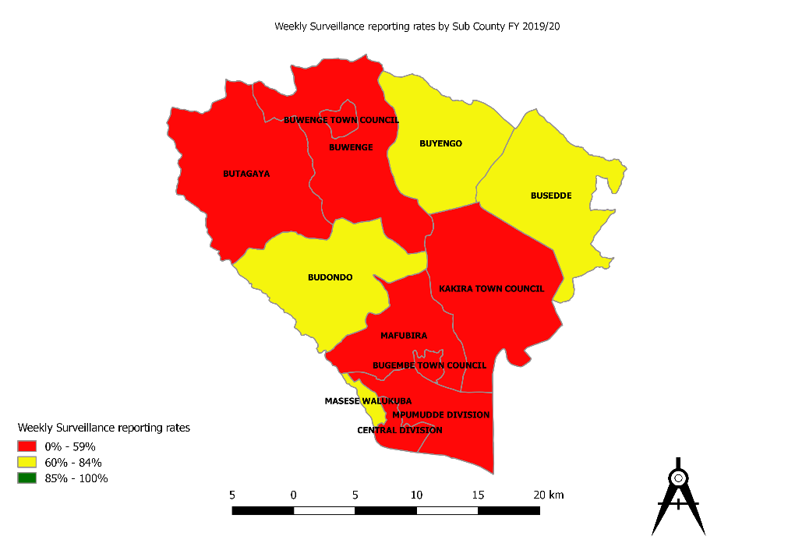
The district reporting rates for both Outpatient report (HMIS 105) and HIV/AIDS services report for FY 2019/2020 were 98%. However the surveillance reporting rates remain low at 52%

Challenges
The challenges encountered by the district health sector include, but are not limited to the following: the low capacity of staff to capture and report data accurately using the current HMIS tools and this consequently affects the output indicators, late submission of reports by health facility managers, inadequate financial resources to conduct supportive supervision in data management and poor data utilization at health facility level.
In summary, the district health sector performed fairly on most of the output indicators as indicated in the summary table below:

Summary of performance
 | Indicator | Target (%) | Achievements (%) | Color code
1 | Antenatal 4⁺ Visit | 65 | 42
2 | Immunization (PCV3) | 100 | 85
3 | Supervised Delivery (health facility) | 92 | 100
4 | HIV positive women initiated on ART | 95 | 97
5 | HIV positive individuals initiated on ART | 95 | 77
6 | Disease Surveillance reporting | 85 | 52
7 | Health facilities tracking & reporting staff attendance to duty in public health facilities | 100 | 86
8 | Availability of tracer medicines in public facilities | 95 | 29
9 | TB treatment Success Rate | 80 | 64
10 | Malaria cases treated based on lab test | 90 | 99
11 | HMIS timeliness and completeness | 97 | 98

