JINJA DISTRICT ANNUAL HEALTH SECTOR PERFORMANCE REPORT

FY 2019/2020

Contents
1 Introduction 2
1.1 Demographic composition 2
1.2 Morbidity 2
1.3 Mortality 2
2 Progress on Key performance indicators 2
2.1 Maternal and child health 2
2.1.1 ANC attendance 2
2.1.2 ART initiation among HIV+ pregnant women 2
2.1.3 Supervised deliveries 2
2.1.4 Post natal attendances 3
2.1.5 ART initiation rates at ANC,MAT and PNC 3
2.1.6 Early infant diagnosis of HIV 3
2.1.7 Immunisation 3
2.2 Malaria 3
2.2.1 Malaria testing and treatment 3
2.2.2 Malaria channel 4
2.3 Tuberculosis 4
2.3.1 Case notification rates 4
2.3.2 Treatment outcomes 4
2.3.3 Treatment Success rate by HF 4
2.4 HIV/AIDS 4
2.4.1 ART initiation rates by S/C 4
2.4.2 ART Retention rates by S/C 5
2.5 Reporting rates 5
3 Medicines availability 5
4 RED performance for FY 2019/2020 5
5 Summary of performance 6

Introduction
The Annual Health performance report for Jinja is compiled to highlight progress, lessons learnt and challenges and propose ways of moving the health sector forward in relation to the National Development Plan (NDP), National Health Policy, the Health Sector Development plan and annual work plan.
The report mainly focuses on the progress of the annual work plan as well as overall health sector performance against the district targets set for the FY 2019/2020. The analysis has taken into account trends of the year under review as well as comparing the previous year.
The objective of the report is to review the performance of the sector for the FY 2019/20 against targets for the core indicators, mostly adopted from the national health sector priorities.
The information used in compiling the annual report is only both quantitative. This report uses the HMIS aggregated periodic reports from the District Health Information Software (DHIS)-2 for the entire FY.

Demographic composition
Demographic Variable | Proportion | Estimated Population
Total Population | 100% | 518,330
Children below 18 years | 56% | 290,265
Adolescent youth (10-24 yrs) | 34.70% | 179,861
Orphans (for children below 18yrs) | 10.90% | 56,498
Infants below 1 year | 4.30% | 22,288
Children below 5 years | 20.50% | 106,258
Women of reproductive age | 47.80% | 247,762
Expected number of pregnancies | 5% | 25,917
Number of expected births | 4.90% | 25,398
People under 15 years of age | 46% | 238,432
Estimated PLHIV | 3.50% | 18,142

Morbidity
The leading cause of morbidity was common colds followed by Malaria in both under 5 years and above 5 years. Diarrhea acute contributed 10% in under 5 years while UTIs contributed 8% in above 5years.
Under 5 | % | Above 5 | %
Colds | 35% | Colds | 33%
Malaria | 32% | Malaria | 32%
Diarrhea acute | 10% | UTI | 8%
Intestinal worms | 7% | Intestinal worms | 6%
Pneumonia | 7% | Skin diseases | 4%

Mortality
The leading cause of mortality in both categories was malaria contributing at least 50%.
Under 5 | % | Above 5 | %
Malaria | 50% | Malaria | 57%
Pneumonia | 17% | Urinary Tract Infections | 9%
Acute diarrhea | 12% | Respiratory infections | 8%
Respiratory Infections | 10% | Pneumonia | 7%
Septicemia | 9% | Typhoid fever | 4%

Progress on Key performance indicators

Maternal and child health

ANC attendance
All the expected pregnant women attended at least first ANC which is 100% and 17% of these were teenagers, a slight decline from 18% in FY 2018/19. The proportion of those who attended the 4 antenatal visits reduced from 79% in FY 2018/19 to 77% in FY 2019/20
The number of pregnant women who attended more than 4 ANC visits also increased from 38% in FY 2018/19 to 42% in FY 2019/20. This is still low especially in line with the World Health Organization recommendation that a pregnant woman should have at least 8 contacts with the health system before delivery. This low attendance could be attributed to the women not starting attendance of ANC early in the first 3 months of pregnancy (1st trimester) as evidenced by the low coverages although we see an improvement from 27% in FY 2018/19 to 49% in FY 2019/20.

ART initiation among HIV+ pregnant women
Pregnant and lactating women who are identified HIV positive are supposed to be initiated on lifelong ART treatment. It’s recommended that 95% of the HIV positive pregnant and lactating women identified are initiated on ART. In FY 2019/20, the health sector was able to initiate 97% of the HIV positive pregnant women on ART an improvement from 89% in FY 2018/19.

Supervised deliveries
Supervised deliveries in both private and public health facilities in FY 2019/20 was 92% of the targeted deliveries a slight decline from 94% in FY 2018/19. The teenage deliveries stagnated at 17% in FY 2019/20 as was the case in FY 2018/19. However the sub counties of Budondo, Butagaya and Buwenge need some targeted interventions to reduce the teenage deliveries. ART coverage among HIV+ mothers in maternity improved from 98% in FY 2018/19 to 100% in FY 2019/20.
The health Sector Development plan targets to have atleast 50% of health centre IVs offering Comprehensive Emergency Obstetric Care (CeMOC). In Jinja only 60% of health centre IVs are able to offer that service. UNICEF/WHO/UNFPA recommend a C-section rate between 5 and 15 percent of all births and the average rate registered by the district was 12% slightly lower than the 15% registered in FY 2018/19.

Post natal attendances
The pregnant women attending postnatal clinics were extremely low especially the attendance at 6 days and 6 months.

ART initiation rates at ANC,MAT and PNC
Pregnant and lactating women identified HIV+ are expected to be initiated on life long treatment to prevent mother to child transmission of HIV. The graph below shows the initiation rates at the 3 entry points for pregnant and lactating women. The overall performance of the option B+ program was 94% in FY 2019/20 a slight decline from 96% in FY 2018/19

Early infant diagnosis of HIV
HIV exposed infants who received 1st DBS between 6-8 weeks increased from 78% in FY 2018/19 to 98% in FY 2019/20. The HIV positivity rate among HIV exposed infants at the 1st test (PCR) was 3% on average an improvement from 6% in FY 2018/19. The ART initiation of the HIV positive infants increased from 85% in FY 2018/19 to 100% in FY 2019/20.

Immunisation
The health sector was expected to immunise 22,288 children under one year of age with DPT, Measles, PCV and others. DPT1 coverage was over 100% (n=22,288), DPT3 coverage was 85% (n=19031) vs a target of 100%, PCV3 coverage was 85% (n=19014) against a target of 100% and measles coverage was 79% (n=17564) against a target of 90%. The DPT dropout rate was 10% which means that the utilisation of immunisation services is still poor. Girls in school who have not had a sexual debut are expected to be vaccinated with HPV to prevent cervical cancer. The expected number of girls to immunise was 8293 and the performance was appalling for both doses i.e HPV1 was 32% while HPV2 was 33%

Malaria
Malaria cases identified per 1000 population were 285 which is above the national target of 198 per 1000. The burden by sub county is shown in the map
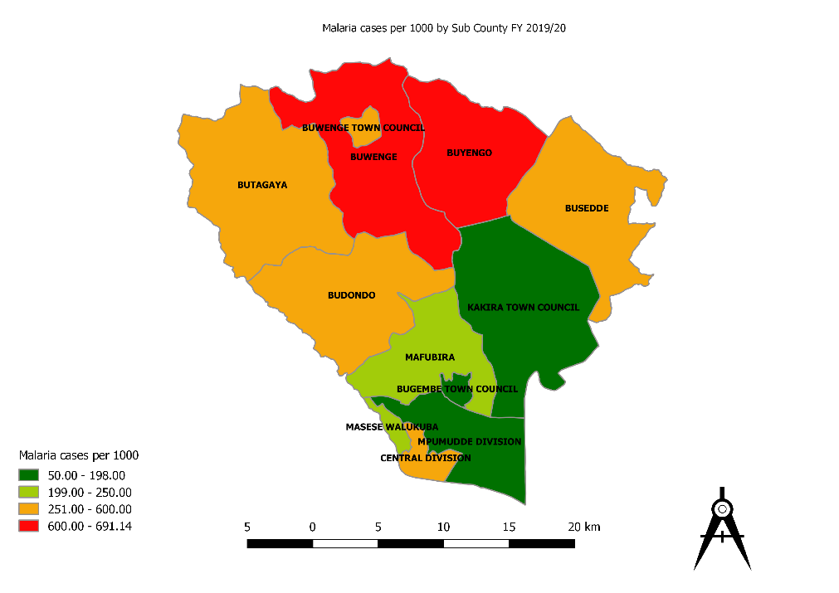

Malaria testing and treatment
The malaria testing rates have reduced from 76% FY 2018/19 to 70% in FY 2019/20. The proportion of malaria cases treated based on a positive lab test have improved from 79% in FY 2018/19 to 99% in FY 2019/20.

Malaria channel

The malaria channel shows reduced malaria cases over time probably due to the mass distribution of mosquito nets.

Tuberculosis

Case notification rates
The district notified 100% of all the expected forms TB. This was majorly because of the referral hospital which receives cases from both within and outside the region. 44% of the cases notified were paediatric cases. However the sub counties of Mafubira, Kakira, Buyengo, Buwenge Rural, Butagaya and Busedde were below their target.
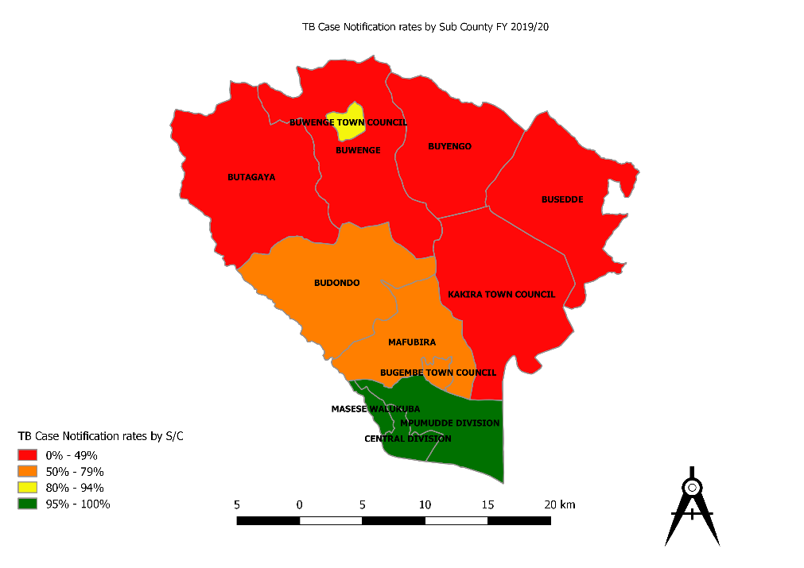

Treatment outcomes
The treatment success rate increased from 53% in FY 2018/19 to 64% in FY 2019/20. However this is still below the national target of 90% as well as the district target of 80%. The cure rate for pulmonary TB was 47% in FY 2018/19 against a target of 65%.

Treatment Success rate by HF

HIV/AIDS
The health sector managed to initiate 77% of the identified HIV+ clients on ART treatment. In addition, 73% of clients who were put on treatment one year back were still alive on treatment.

ART initiation rates by S/C
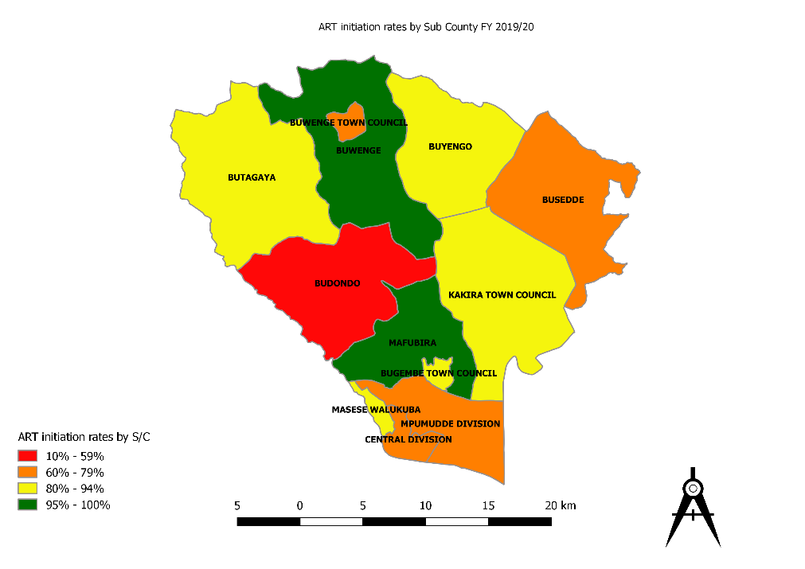

ART Retention rates by S/C

Reporting rates
The reporting rates were analysed for 4 key routine reports i.e weekly surveillance report (HMIS 033B), quarterly VHT/ICCM report (HMIS 097), OPD report (HMIS 105) and the quarterly HIV & TB services report (HMIS 106a). The situation did not change much from the previous financial year especially with the Surveillance weekly report. However although the quarterly VHT/ICCM reporting rates were low at 35%, there is an improvement worth noting from 19% in FY 2018/19.
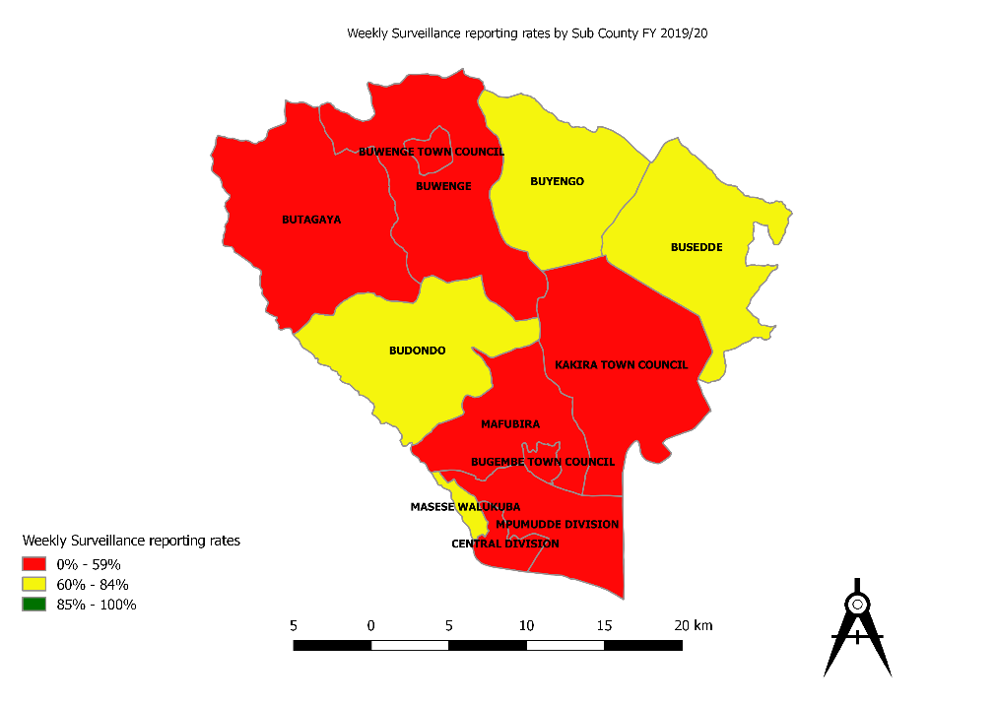

Medicines availability
29% of the health facilities reported no stock out of the essential medicines listed in the table below
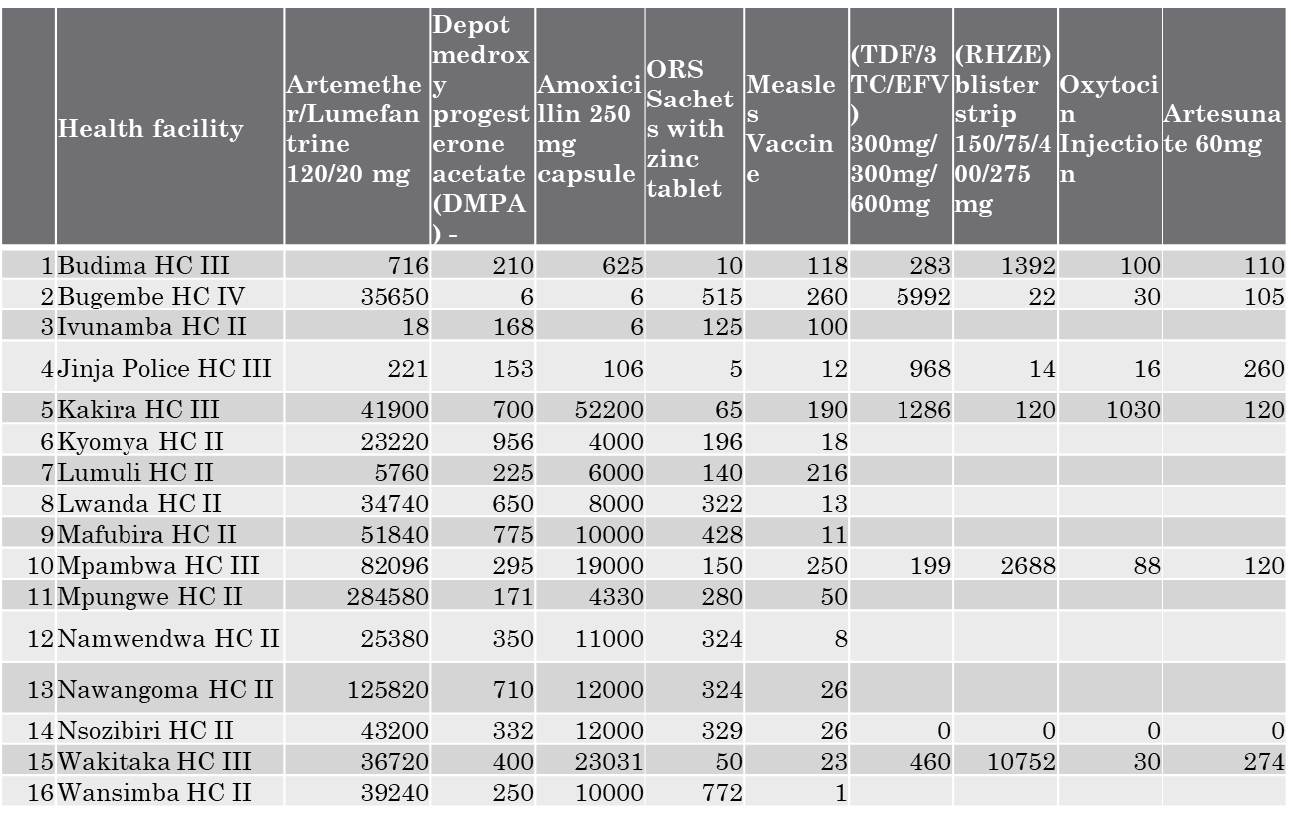

RED performance for FY 2019/2020

Summary of performance
The health sector performance was fair on average considering the performance indicators listed in the table below.
Indicator | Achievement | National target | Color code
Maternal Mortality Rate | 249/100,000 | 320/100,000
Neonatal Mortality Rate | 8/1,000 | 16/1,000
Under 5 mortality rate | 6/1,000 | 51/1,000
Teenage pregnancy rate | 17% | 14%
ART initiation rate | 77% | 80%
Option B+ | 97% | 95%
IPT3 coverage | 28% | 93%
Malaria deaths per 100,000 | 15/100,000 | 5/100,000
Malaria cases per 1000 | 285/1000 | 198/1,000
Vitamin A 2nd dose coverage | 14% | 66%
DPT3 | 85% | 97%
Measles Rubella 1 | 79% | 95%
Average Length of Stay | 15 | 3
Bed Occupancy Rate | 36% | 90%
CPR | 53% | 56%
ANC4+ coverage | 42% | 45%
Supervised deliveries | 94% | 64%
Health Centre IVs providing CEMOC | 60% | 50%
Fresh Still birth rate | 8/1000 | 11/1000
Under 5 deaths among 1000 under 5 admissions | 17/1000 | 16.1/1000
ART retention rate | 73% | 84%
TB TSR | 64% | 90%
Health facilities reporting no stock out of essential medicines | 29% | 100%

